# Chapter 9

# Project Output

* **Login Page**

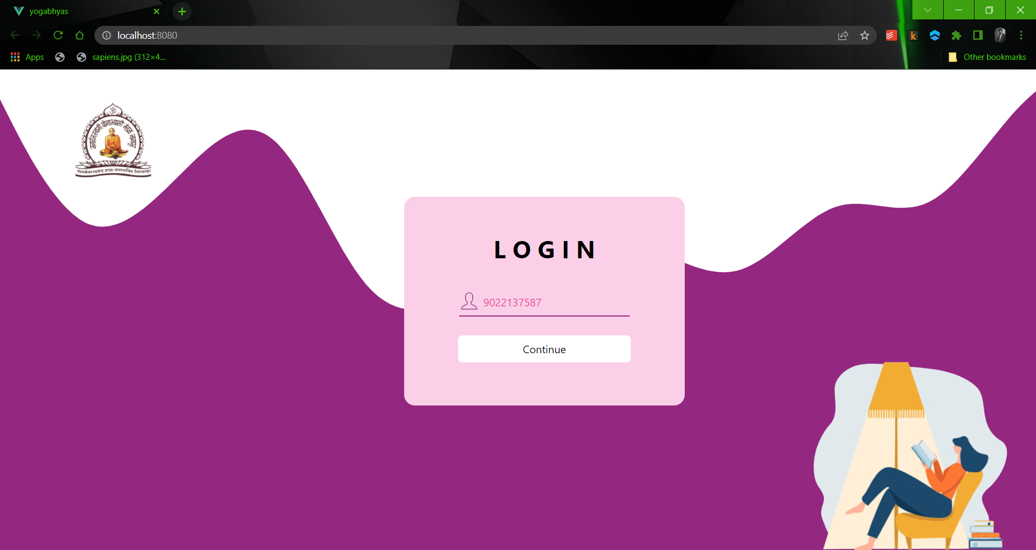

*Fig 9.1 Login Page*

* **Register Page**

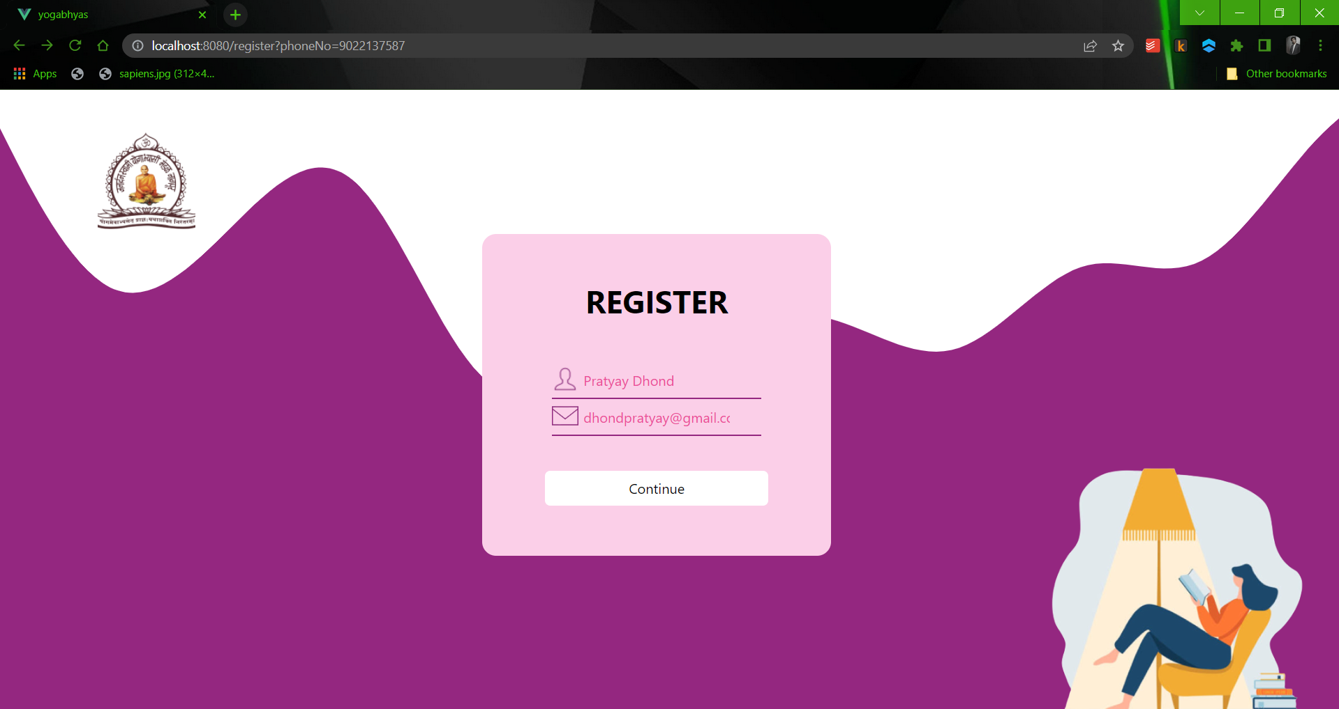

*Fig 9.2 Register Page*

* **Address Page**

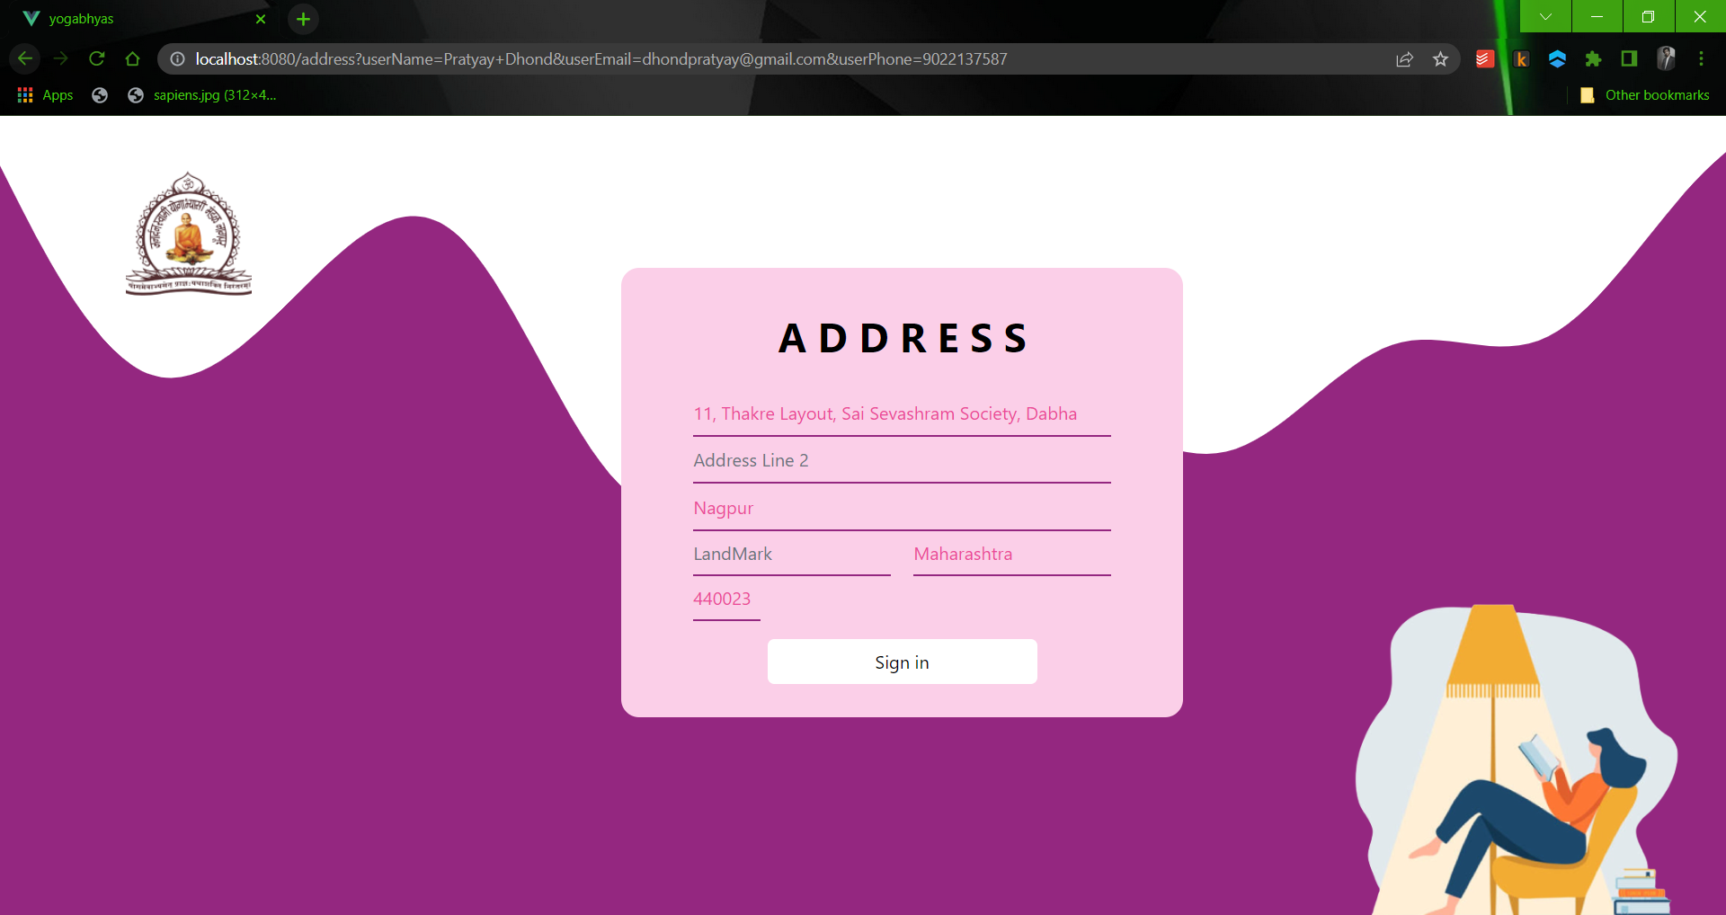

*Fig 9.3 Address Page*

* **Otp Page**

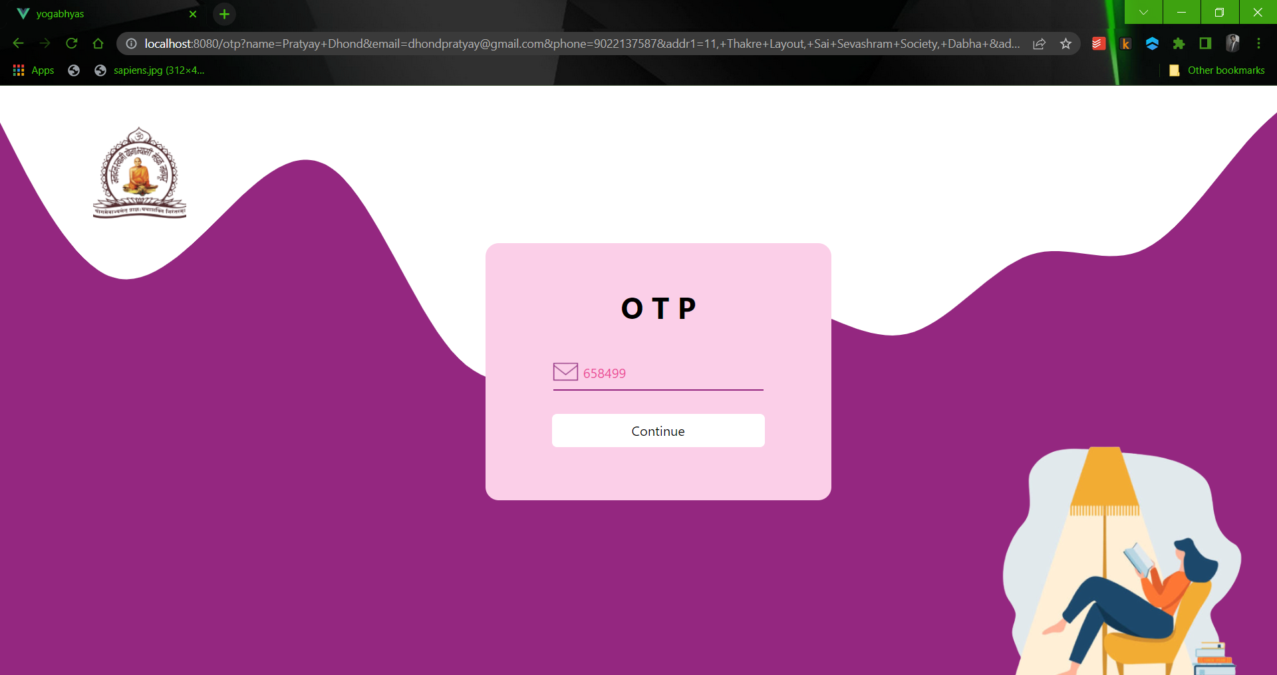

*Fig 9.4 OTP Page*

* **Home Page**

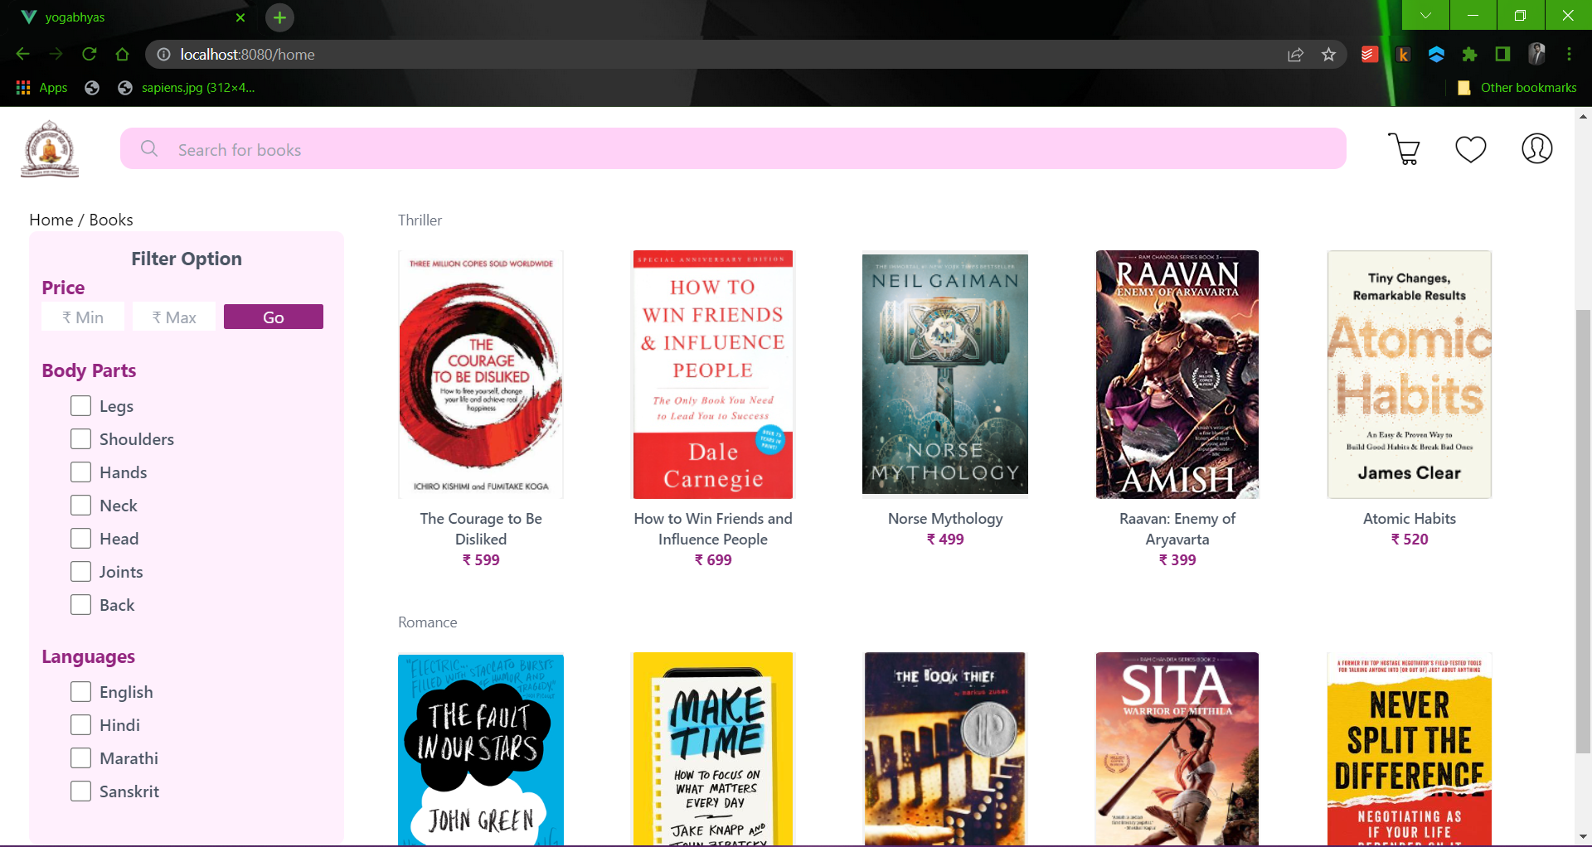

*Fig 9.5 Home Page*

* **Book Page**

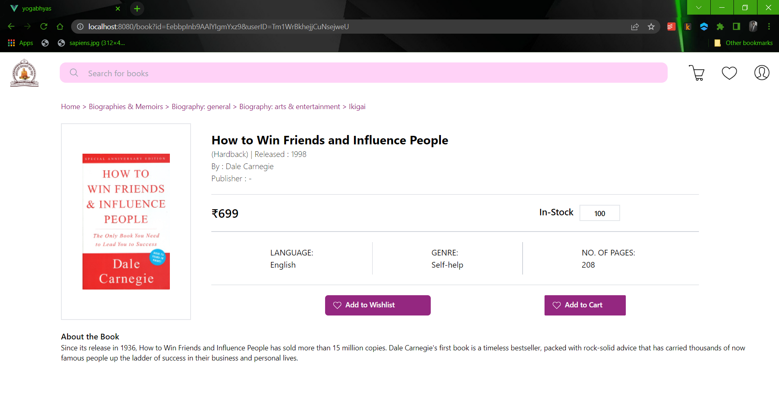

*Fig 9.6 Book Page*

* **Search Result Page**

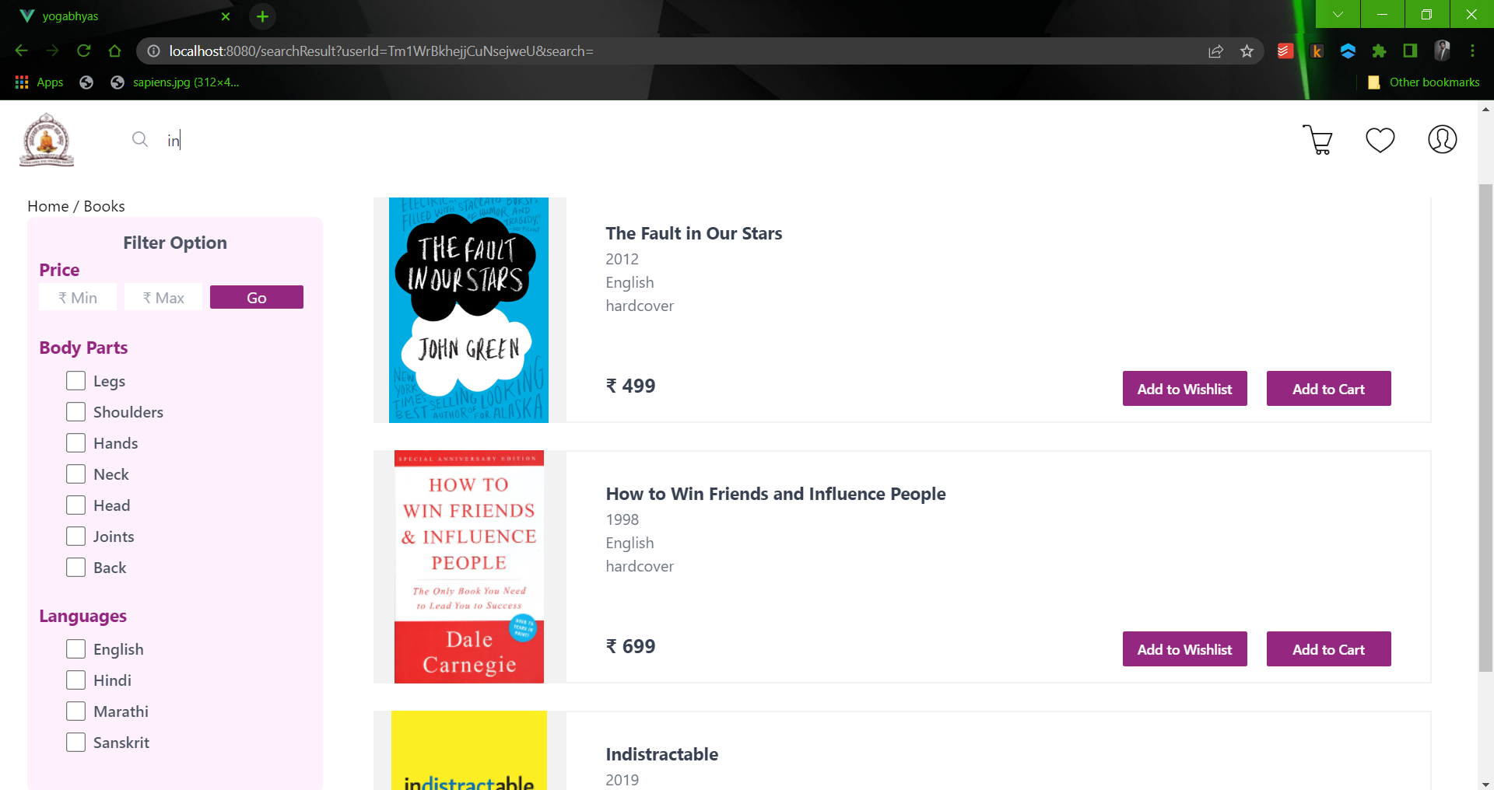

*Fig 9.7 Search Result Page*

* **Cart Page**

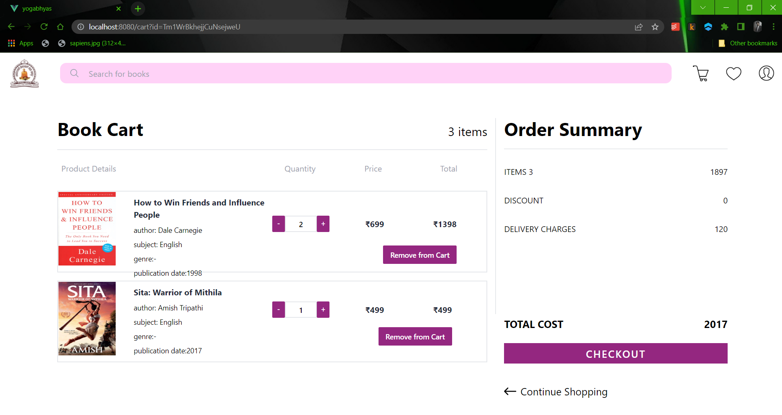

*Fig 9.8 Cart Page*

* **Wishlist Page**

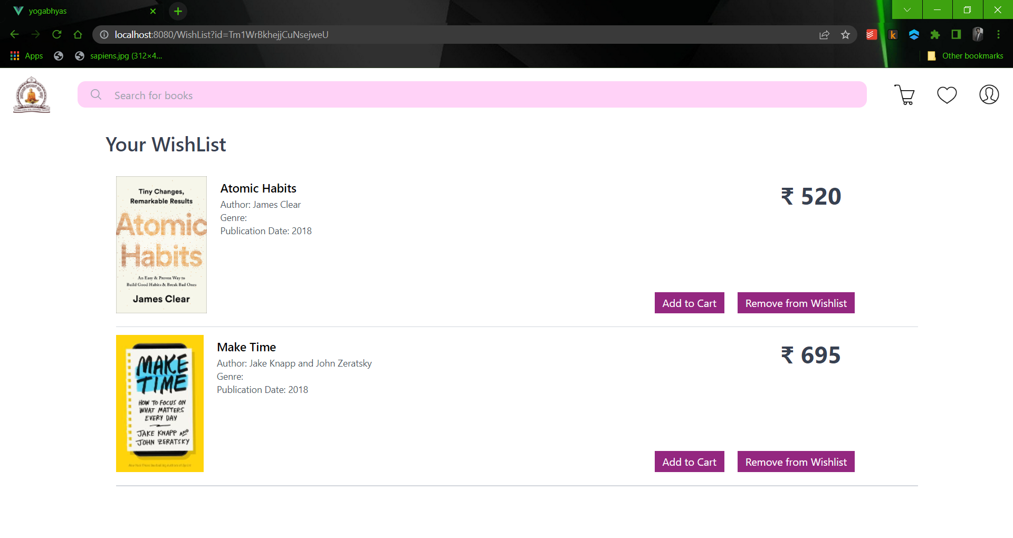

*Fig 9.9 WishList Page*

* **User Profile Page**

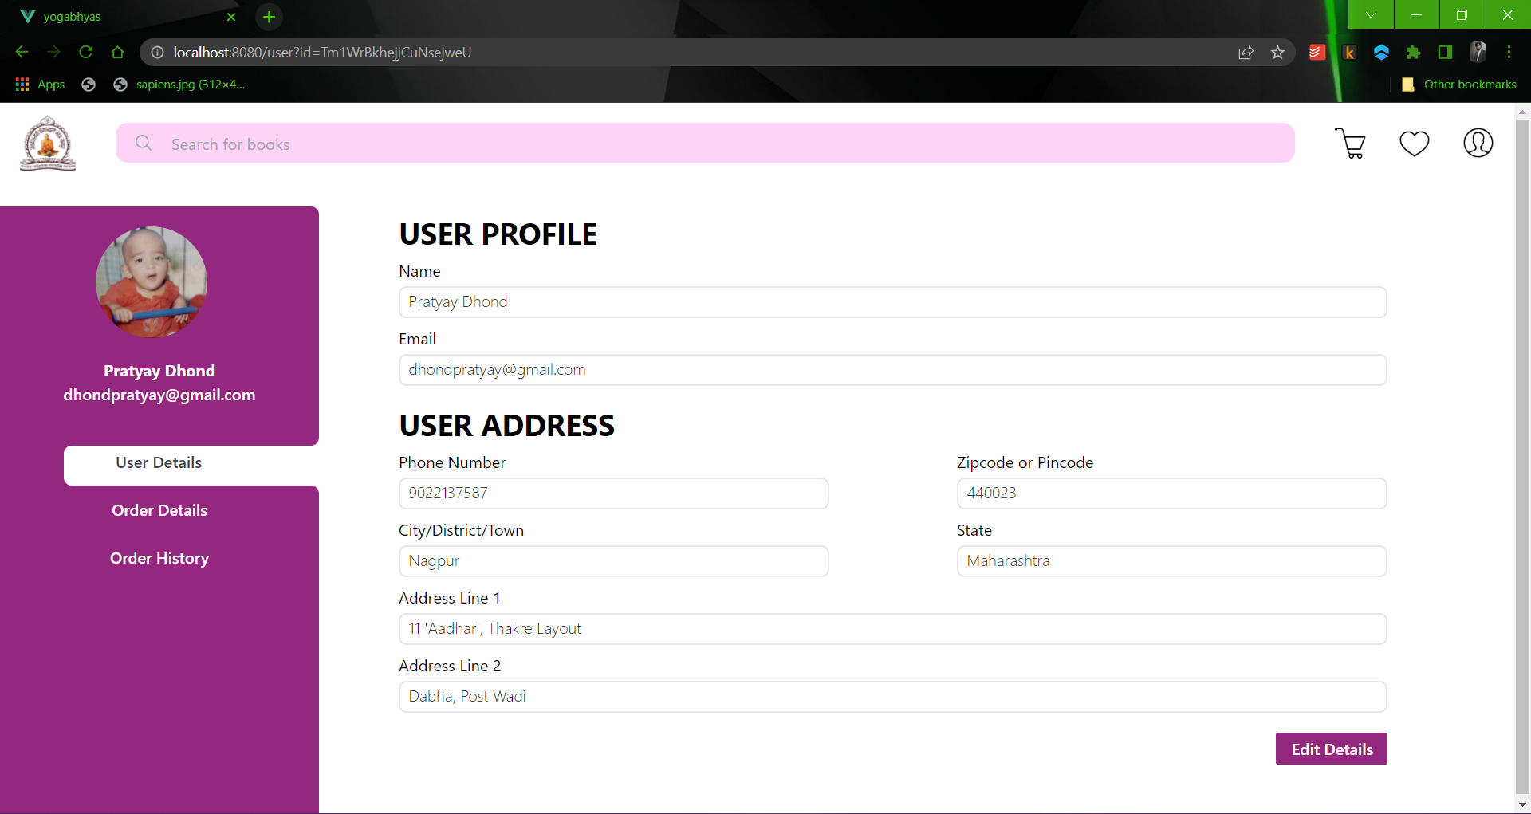

*Fig 9.10 User Profile Page*

* **User Profile Edit Page**

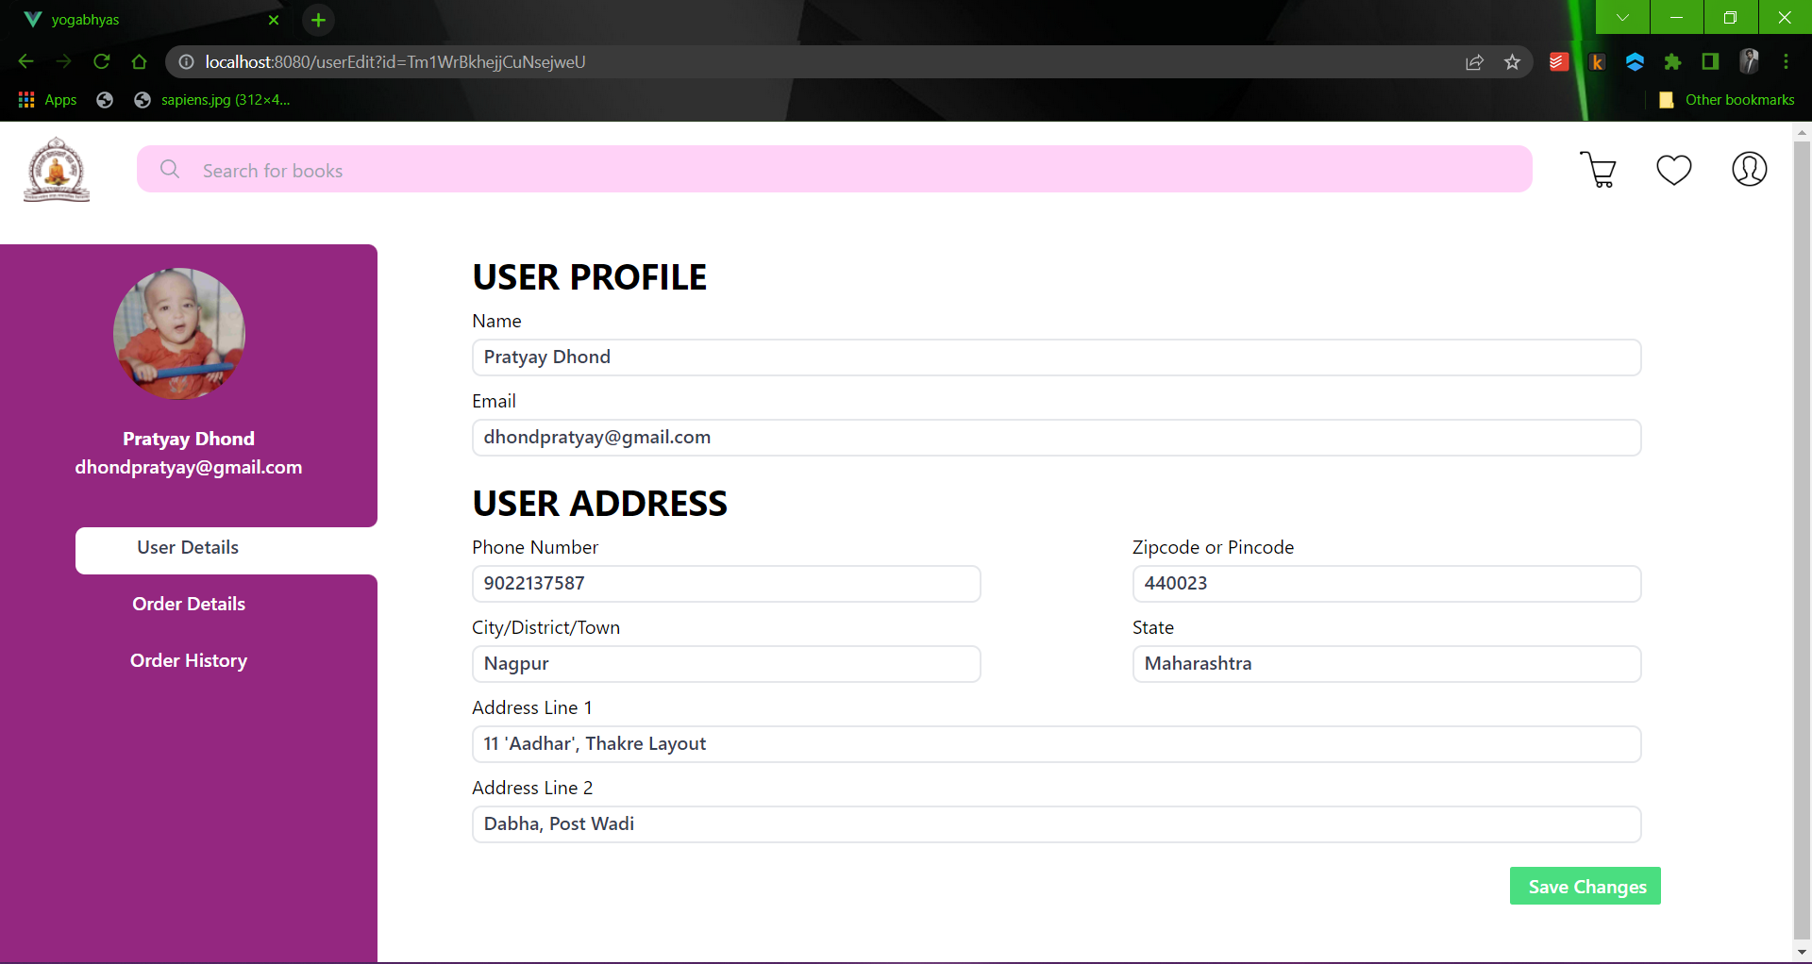

*Fig 9.11 User Profile Edit Page*